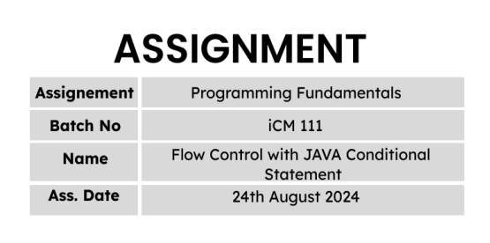

import java.util.*;

class Coursework4{

public static void main(String args[]){

Scanner input = new Scanner(System.in);

System.out.println("--------------------------------------------------------");

System.out.println("| SALARY INFORMATION SYSTEM |");

System.out.println("--------------------------------------------------------");

System.out.println("\t[1] Calculate Income Tax");

System.out.println("\t[2] Calculate Annual Bonus");

System.out.println("\t[3] Calculate Loan Amount");

System.out.print("\nEnter an option to continue : ");

String option = input.next();

if (option.equals("1")){

System.out.println("\n\n--------------------------------------------------------");

System.out.println("| Calculate Income Tax |");

System.out.println("--------------------------------------------------------");

System.out.print("\nInput Employee name - ");

String name = input.next();

System.out.print("Input Employee salary - ");

double salary = input.nextDouble();

double tax = 0;

if (salary >= 0 && salary <= 100000){

tax = 0;

}else if (salary > 100000){

if ((salary - 100000) >= 41667){

tax += 2500;

if ((salary - 100000) >= 83333){

tax += 7500;

if ((salary - 100000) >= 125000){

tax += 15000;

if ((salary - 100000) >= 166667){

tax += 25000;

if ((salary - 100000) >= 208333){

tax += 37500;

if((salary - 100000) >= 266667){

tax += (salary - 350000) * 36 / 100;

}

}else{

tax += (salary - 266667) * 30 / 100;

}

}else{

tax += (salary - 225000) * 24 / 100;

}

}else{

tax += (salary - 183333) * 18 / 100;

}

}else{

tax += (salary - 141667) * 12 /100;

}

}else{

tax += (salary-100000) * 6 / 100;

}

System.out.println("\nYou have to pay Income Tax per month : " + tax);

}else{

System.out.println("Invalid input!");

}

}else if (option.equals("2")){

System.out.println("\n\n--------------------------------------------------------");

System.out.println("| Calculate Annual Bonus |");

System.out.println("--------------------------------------------------------");

System.out.print("\nInput Employee name - ");

String name = input.next();

System.out.print("Input Employee salary - ");

double salary = input.nextDouble();

double bonus = 0;

if (salary >= 0 && salary <= 100000){

bonus = 5000;

}else if (salary >= 100000){

bonus += 5000;

if (salary >= 199999){

bonus += (99999* 10 / 100);

if (salary >= 299999){

bonus += 99999 * 15 / 100;

if (salary >= 399999){

bonus += 99999 * 20 / 100;

if (salary >= 400000){

bonus += (salary - 399999) * 35 / 100;

}

}else{

bonus += (salary - 300000) * 20 / 100;

}

}else{

bonus += (salary - 200000) * 15 /100;

}

}else{

bonus += (salary - 100000) * 10 / 100;

}

}else{

System.out.println("Invalid input");

}

System.out.println("\nAnnual bonus - " + bonus);

}else if (option.equals("3")){

System.out.println("\n\n--------------------------------------------------------");

System.out.println("| Calculate Loan amount |");

System.out.println("--------------------------------------------------------");

System.out.print("\nInput Employee name - ");

String name = input.next();

System.out.print("Input Employee salary - ");

double salary = input.nextDouble();

double loan;

if (salary >= 50000){

double rate = 15.0 / 100;

double monthly_installement = salary * 0.6;

System.out.print("Input the number of years - ");

int years = input.nextInt();

int months = years * 12;

if (years > 0 && years <= 5){

loan = monthly_installement * (1 - Math.pow((1 + (rate / 12)),-months)) / (rate / 12);

System.out.printf("\nYou can get Loan Ammount : %.2f" ,loan);

}else if(years > 5){

System.out.println("\nMaxumum number of years should be 5. ");

}else{

System.out.println("\nInvalid input");

}

}else if (salary < 50000){

System.out.println("\nSalary should greater than 50000");

}else{

System.out.println("\nInvalid input");

}

}

}

}